Business Process Definition – BPDs
业务流程定义-BPDs
The Business Process Definition (BPD) is the the core of an IBM BPM solution. The BPD represents the model of the business process and is captured early on in the design of the solution. It also allows the process to be easily modified as time passes. At a high level, a BPD is a diagram that represents the overall view and flow of the process. It is commonly constructed by the Business Process Analyst in conjunction with discussions and interviews with other members of staff.
业务流程定义（BPD） is IBM PBM 解决方案中比较核心的一块，它代表着业务流程中的模型，因为它可以在任何时候很简单的去修改流程,因此 最早是被用于方案设计。从一个高的级别来看，一个PBD 就是一个代表着视图大纲和流程图的图表，业务流程分析人士一般会结合和其他员工的讨论或者面试使用。

Here is an example of a napkin sketch of a trivial business process for approving a loan. We could imagine a meeting room with a white board where the process of how a loan is handled is discussed. The flowchart like blocks could be drawn on a white board.
下面是一个画在餐巾纸上关于贷款的流程审批的小例子，我们可以做一个想象，在一个有一个白板的会议室，大家都在讨论如何处理贷款审批。整个流程闭塞的画在一个白版上。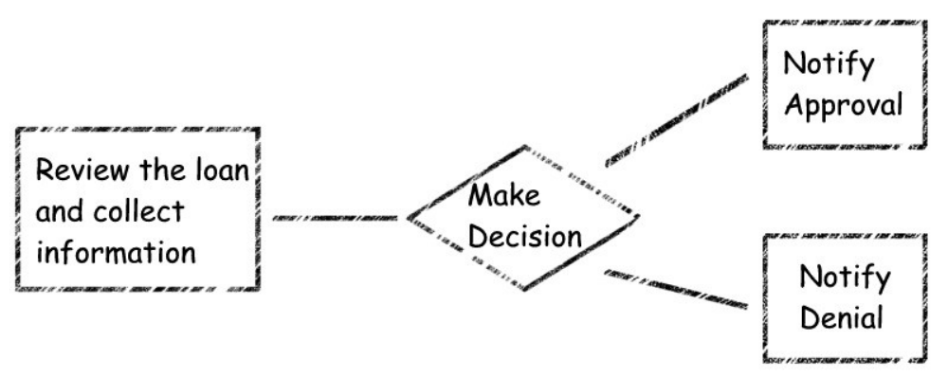

In IBPM, the exact same process can be captured as a Business Process Definition in the IBPM Process Designer (PD) tooling. It captures the exact same essence of the process. In fact, it is arguably easier to capture the process in IBPM PD as blocks can be moved around without having to erase the picture and redraw it.
在BPM 里面，相同并且更加准确的流程可以作为一个BPD 在IBPM 流程设计（PD） 的工具中获得.PD 可以准确的描述出相同最精华的流程。事实上，PD 可以在IBPM PD 里面更容易的设计出一个流程，并且可以随意的去修改它而不需要像白版那样，擦去重画。

We will further see later that participants at the meeting where the process is being sketched can be remote from each other and yet the same process diagram can be seen on each of their screens.
我们随后将会看到，每一个与会者都会看到一个展开的流程图，并且同样的流程图也可以显示在他们每一个人的屏幕上。

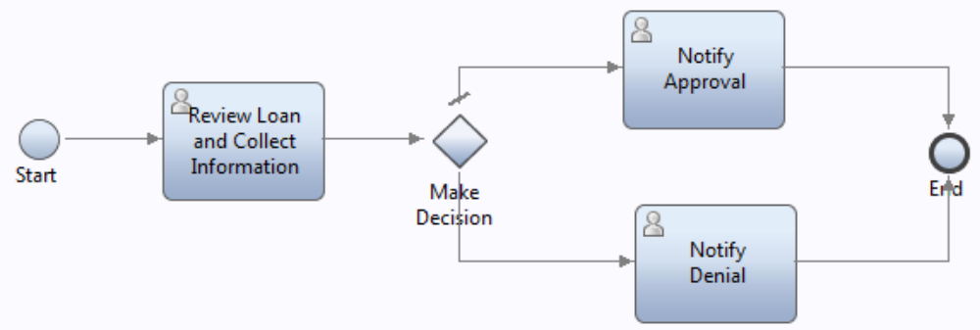

The diagram style of a Business Process Definition conforms to the industry standard Business Process Model and Notation (BPMN) format.
See also:

Modeling a process BPD
图表类型遵守产业业务流程模型和符号格式标准（BPMN ）
看下面：
流程建模
When a Business Process Definition is created it is given a name and lives inside a Process Application solution. A Business Process Definition is created inside the IBPM PD tooling from the library section within the Processes category:
当一个业务流程定义被创建的时候，它会要求赋予一个名字，并且存在一个应用流程方案里面，一个BPD被创建在IBPM PD 工具里一个装有流程分类的文库里面：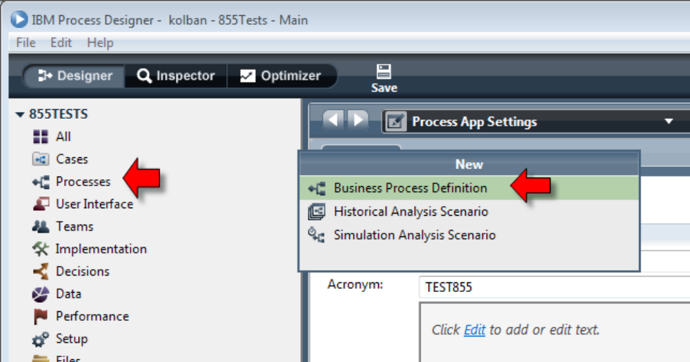

The wizard for the Business Process Definition (BPD) asks for the name of the new BPD which is to be created.
BPD 创建的界面上会要求给一个需要创建的BPD 的名字：
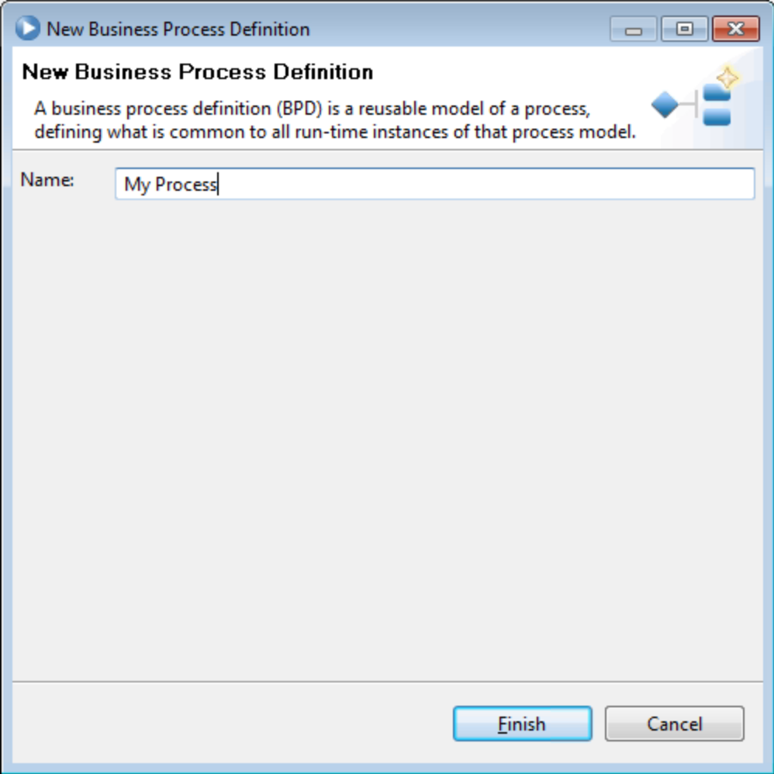

Once created, the main canvas area of the BPD editor is shown:
一但创建成功，BPD 编辑的主页将显示如下
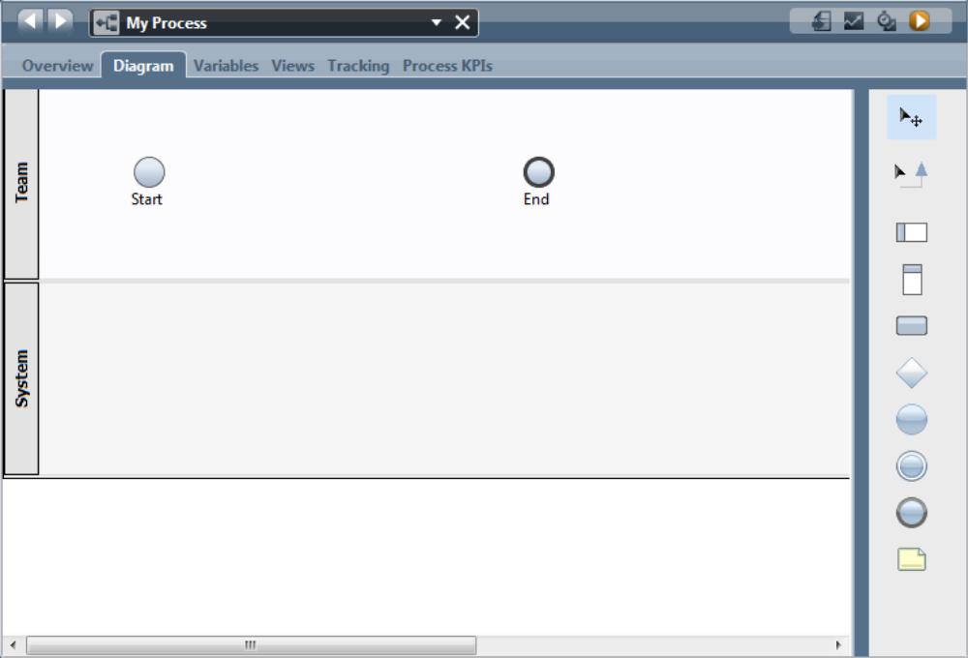

This main area of the window is called the canvas and is where we visually model the process solution we wish to construct. Icons representing the activities and other elements of the process can be dragged from the palette of available types shown on the right of the window. These icons can be dropped onto the canvas and wired into place using Sequence Lines. Each icon represents a "step" in the process.
窗口主要的区域可以被叫做一块画板，并且，我们可以在上面构造我们想要的流程方法。图标代表一些活动，其他的元素可以从右边窗口各种变量类型的调色板上拖到过来，这些图表也可以从画板中删掉，或者序列线连起来放在一边。每一个图表在流程中各自代表这个流程中的一个“步骤”。

The icons conform to the Business Process Model and Notation (BPMN) style and their interpretation is also that of BPMN.
- Activity – see Activities
- Lane – see Pools and Lanes
- Milestone – see Pools and Lanes
- Decision Gateway – see Gateways, Conditionals and Joins
- Note
- Start Event – see Start Event
- End Event – see End Event
 Intermediate Event

图标也遵守 业务流程模型和符号(BPMN）风格 并且 他们翻译出来的也是BPMN类型

- 活动-参考下面活动
- 通道 – 参考池与通道
- 里程碑 – 参考池与通道
- 决策网关 – 参考 网关，条件和连接

 记事本
- 起始事件 – 参考起始事件

 结束事件 – 参考 结束事件
中间件事件

Contained within these major palette entries are the other BPMN components:

 |  | Task Types
 |  | User Task
 |  | System Task
 |  | Decision Task
 |  | Script
 |  | Subprocess
 |  | Linked Process
 |  | Event Process
 |  | None
 |  | Gateways
 |  | Exclusive Gateway
 |  | Parallel Gateway
 |  | Inclusive Gateway
 |  | Event Gateway
 |  | Start Events
 |  | None Start Event
 |  | Message Start Event
 |  | Ad Hoc Start Event
 |  | Content Start Event
 |  | Intermediate Events
 |  | Message Intermediate Event (Receive)
 |  | Message Intermediate Event (Send)
 |  | Timer Intermediate Event
 |  | Content Intermediate Event
 |  | Tracking Intermediate Event
 |  | End Events
 |  | None End Event
 |  | Message End Event
 |  | Error End Event
 |  | Terminate End Event

包括下面这些调色板里面主要控件条目是其他BPMN主键

任务类型
用户任务
系统任务
决策任务
脚本
子流程
关联流程
事件流程
空流程
网关
互斥网关
并行网关
相容网关
事件网关
起始事件
无起始事件
消息驱动事件
关联启动事件
内容启动事件
中间事件
消息中间事件（接收）
消息中间事件 (发送)
时间中间事件
内容中间事件
跟踪中间事件
结束事件
空结束事件
消息结束事件
出错结束事件
终止结束事件

See also:
• Sequence Lines

请看下面：
序列线

Pools and Lanes
Think of an Olympics swimming competition where multiple swimmers swim against each other for the fastest time. Each swimmer swims in the same swimming pool but is constrained to swim only in their own swimming lane. The canvas drawing area of the BPD also contains such a model. The canvas as a whole represents the pool while multiple lanes can be added to segment the pool into horizontal sections. When an icon is added to the diagram, its vertical position on the diagram mmeans that it "lives" in only one lane. This serves two purposes. First, if we associate a lane with a particular "role" in the process, then we can quickly see simply by looking along the row of the lane which activities are associated with which roles. Conversely, if we assign attributes to a particular lane, then activities found in that lane can inherit those attributes.
池和通道
试想在奥林匹克运动会的一个游泳竞赛项目中，很多参赛者都在以最快的速度游泳。每一个参赛者都在同一个游泳池，但是必须在自己所在的通道游泳。BPD 中实现的这样一块画板也包含这样一个模型。画板的区域象征着有着很多分割的水平区域通道的游泳池。当一个图标加到图表里面的时候，在这个活动中，它垂直方向的职责在有一个通道中的意思是只能“生活”在这一个通道里，这个服务有两个目的。首先在流程中，如果我们把一个通道和一个特殊的“角色” 联系在一起，我们就很容易看出来哪一个通道对应活动所关联的角色。相反，如果我们把一些属性分配给一个特别的通道，这些活动中可以看到这个通道了继承这些属性。

Here we see an example of a BPD pool with a couple of lanes:
下面我们来看一个拥有一系列通道的BPD 池：

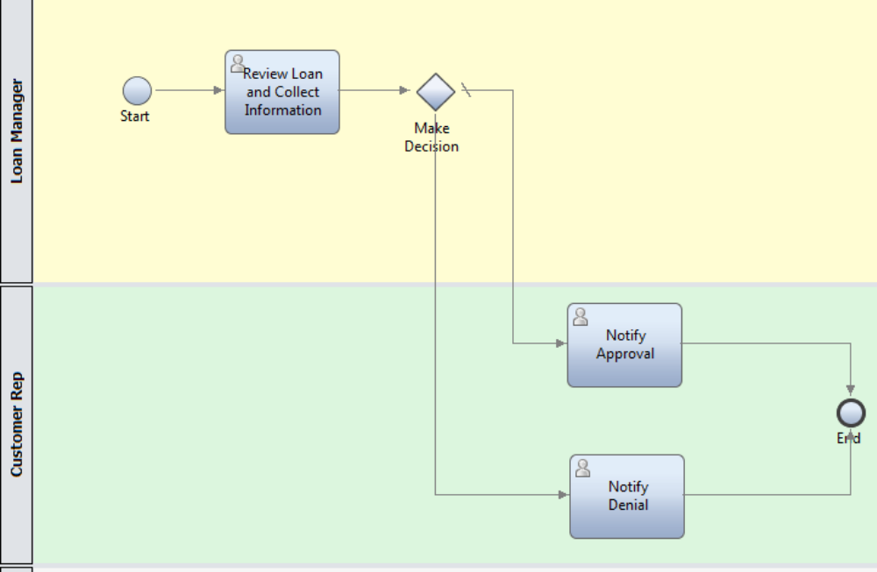

Additional lanes can be added by dragging a lane icon from the tools palette:

同样，一些其他的通道可以从右边的调色板上的通道图标拖到里面：
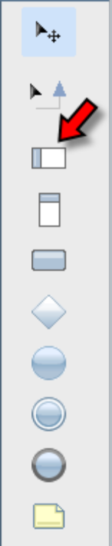

When a lane is added to the diagram we can specify some primary attributes:
当一个通道被加到图表里面之后，我们可以自定义一些简单的属性。

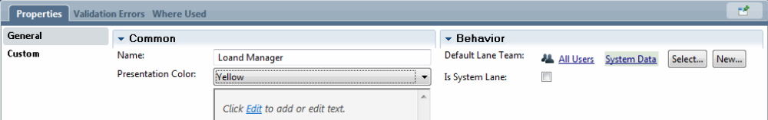

Every lane has a Name attribute so we should supply a meaningful name that will remind us of its purpose. A Presentation Color can be assigned which will change the background color of the lane. This can be especially useful if you have many lanes and need to read to the far right in order to see all of the process content. The Name of the lane may not always be immediately visible but if colored correctly, will highlight its intent.

每一个通道都会有一个名字属性让我们来命名，我们一般起个特别的名字可以标示这个通道的用途。我们也可以通过改变这个通道的背景色给它一个标志性的颜色。当你有很多的通道，为了看所有流程的内容和整个框架的时候，用颜色标示就显得极其方便。通道的名字不一定一眼就显现出来，但是如果颜色标示正确的话，每一个通道的用途就一目了然了。
For human services, we can assign the set of users that should be associated with the lane. This set of users is known as a Team. When a human service is added as a step on the lane, if no specific human routing instructions are supplied, then the human service will be routed to the members of the Team associated with the lane.
对于人工服务，我们可以分配一系列和通道关联的用户。这一系列的用户被命名一个团队。当一个人工服务作为一个步骤被加到一个通道中时，如果没有特别的人员指派说明提供的话，这个人工服务将会被指定到和通道关联的团队人员里。

We can re-order the lanes in a pool from their existing values. By right clicking in a lane, a context menu is shown:
我们也可以从现在在池里面通道的值来调整它们的位置。通过单击通道的右键，右键显示的菜单的内容如下：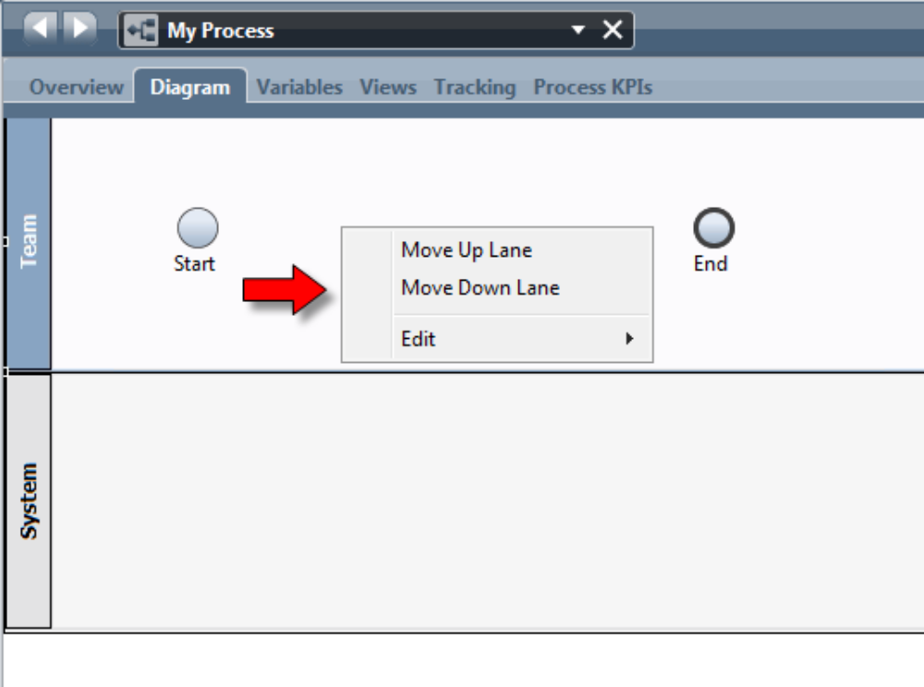

Within that menu we can choose to move the selected lane up or down relative to the other lanes in the pool.
在显示的菜单里面，我们可以选择向上或者向下移动选中的通道并且关联到在这个池里面的其他的通道。

Sequence Lines序列线

The lines which are drawn which connect individual steps in a BPD are called Sequence Lines. A sequence line describes which activities will follow other activities in sequence as the process executes. Sequence lines have an arrow head point to the next activity to be executed. When using PD, the following icon can be used to place the tool into a mode where Sequence Lines can be drawn:
在BPD 里面把各个独自的步骤连接起来画的线叫做序列线。一个序列线描述的是在程序中一个活动会随着其他的活动依次执行。序列线有一个带着箭头的点指向下一个要执行的活动。当在PD 里面使用的时候，下面的图标可以用来放置工具到可以画序列线的模式里


When in sequence line drawing mode, the cursor shape changes to include a "plug" in its visual representation. This is to represent the idea of wiring (or plugging) one component into another. When the cursor is over an element that can be the source or target of a Sequence Line, the element's representation changes to show attachment points.

当序列线处在编辑模式，光标的形状看起来像个“插头”。这代表一种从一个主件连接（或者“插入”）到另一个主件的思想。当光标是一种这样的元素：可以作为序列线的源头或者目标点的时候，这个元素改变时候的表现会显示附着点。

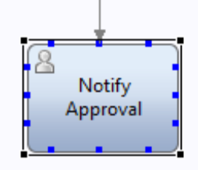

These attachment points serve as the anchors for the start and end of a Sequence Line. To wire two elements together, enter wiring mode and hover the mouse over the originating element. Pick one of the attachment points and click and release. Next move the cursor (without pressing any further buttons) over the target element. A line will automatically be drawn from the source to the target. When over the target, attachment points will again be shown. Pick the attachment point that is desired and click and release once more. A Sequence Line will now connect the two elements.
这些附着点作为序列线开始和结束的锚，用来连接两个元素，连接模式开启的时候，鼠标将停留在原始元素上。选择一个附着点然后点击释放，下移光标（不要点击任何其他的按钮）到目标元素上，连接起始和目标的线就自动画成了。当移动到目标点上，附着点会再次显示出来。选择一个你想连接的附着点 ，点击鼠标再一次释放，一条新的连接两个元素的线将会显示出来。
You can leave wiring mode by clicking on the icon that looks like:
你可以通过点击如下的图标退出画线连接模式。


You can tell which editing mode you are in as the current mode icon has a blue background. Alternatively, when in wiring mode, pressing the Escape key on the keyboard will return you to the default editing mode.
你可以通过当前模式下的蓝色图标的背景色来区分你所处的模式是编辑模式。当然，当在连线模式的时候，按 键盘上的退出键（Esc）也会返回到之前默认的编辑模式。

A Sequence Line can be have its source or target changed. If the line is selected with a mouse click, either endpoint of the line can be dragged to another element.
一个画好的序列线的源和目标也可以改变。如果用鼠标选中徐列线，可以拖动线的末端连接到另一个元素。

From the context menu when a Sequence Line is selected, additional "points" on the line called control points can be added. A control point allows the line to have additional junctions in it to further control its visual layout and appearance. This can be used to make the diagram more attractive. The control point can be dragged with the mouse to re-orient the line.
选中一条序列线单击右键从菜单的内容中可以看到创建控制点。点击创建控制点之后，序列线上会出现一些额外的“点“，这些额外的点叫做控制点。控制点允许线上有额外的连接以进一步控制其布局和外观。这通常被用来画比较美观的图表。控制点可以随着鼠标的拖动而调整线的位置。

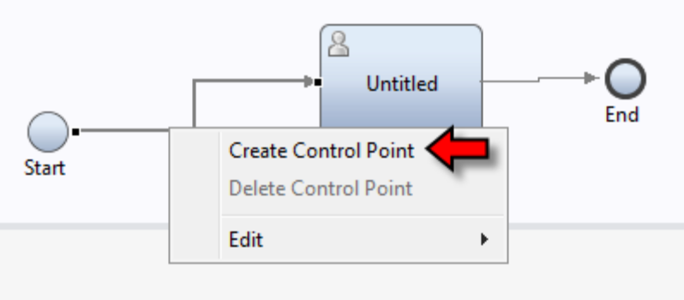

When selected, we can also edit the properties of a Sequence Line:
当序列线被选中的时候，我们还可以编辑序列线的属性
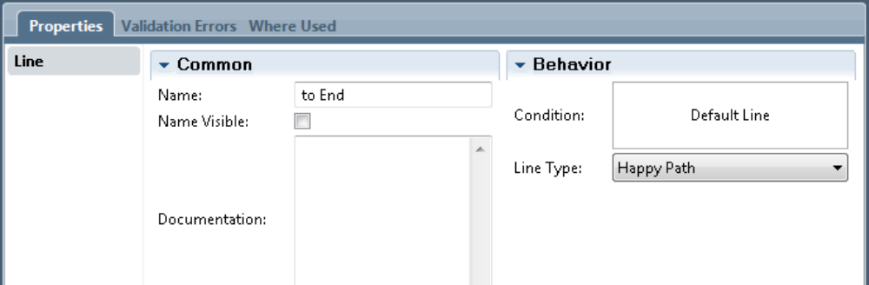

Amongst these properties are the Name that can be given to the line. This name can be made visible and shows on the diagram.
序列线的大部分属性就是这个线的名字。线的名字还可以设置为可见的而且显示在图表上。

Here we see a diagram with the text of the line not visible:
下面我们看到的这个图表中的序列线将是不可见的：

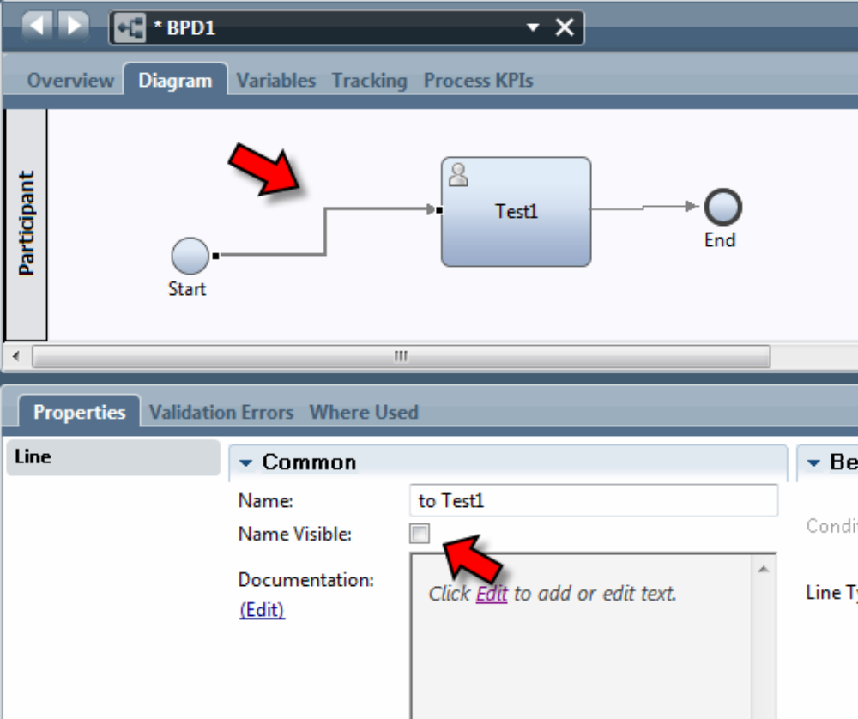
and here is the same diagram with the name visible:

同时我们还有一个图表上的序列线的名字可见的例子 ：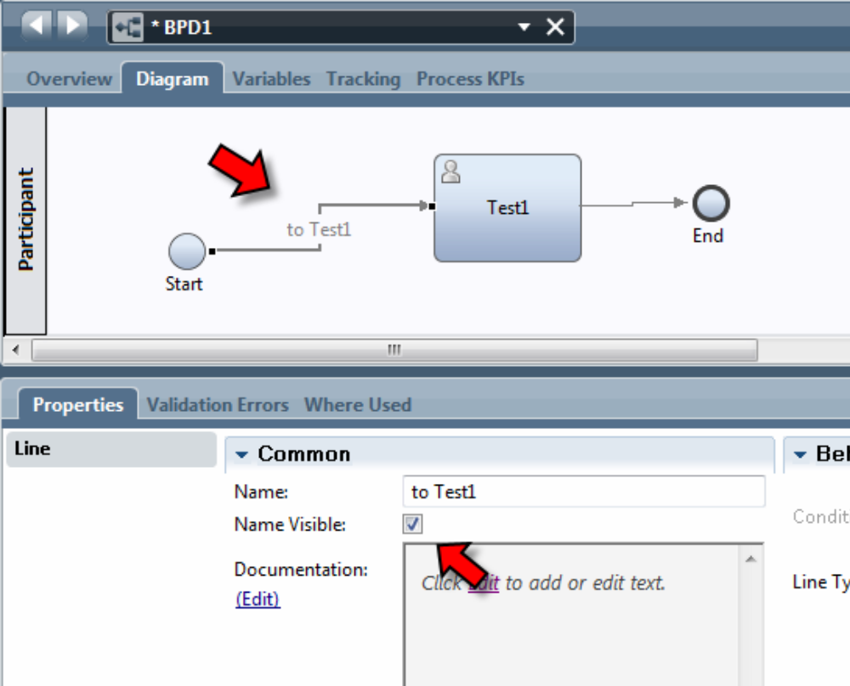

In addition, if the Sequence Line is used as the output of a condition gateway, the name given to the line is seen in the gateway's description of the conditions that are used to select which of the possible alternative paths are to be taken.
此外，如果序列线被用来一个网关输出的条件，这个序列线显示出来的名字取决于网关的描述条件，网关的的条件可能会有很多支路，序列线的名字会根据相应支路的走向来命名。

The condition associated with a decision gateway can also be seen on the properties of the line.
在序列线的属性里，也可以看到相关联的决策网关的条件。

